TDD using JUnit5 and Mockito
Name: NALLANI LOKAKALYAN
Registered Mail: 2300030853cseh1@gmail.com
Exercise 1:Mocking and Stubbing:
Main.java:
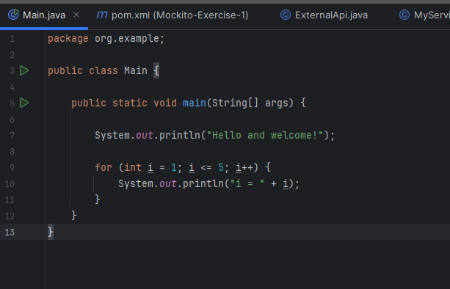Pom.xml: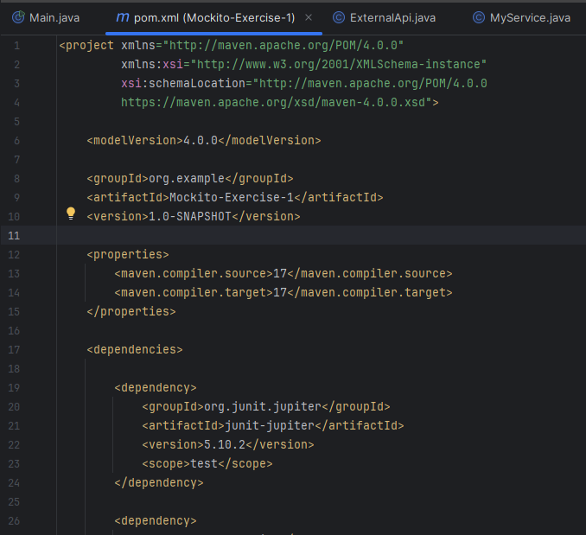
ExternalAPI.java:
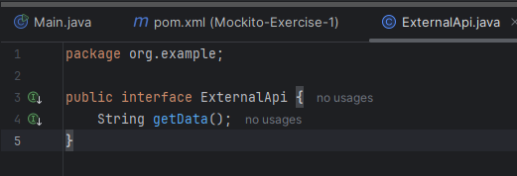

My Service.java:
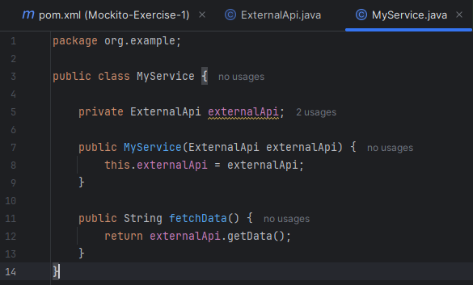
MyServiceTest.java:
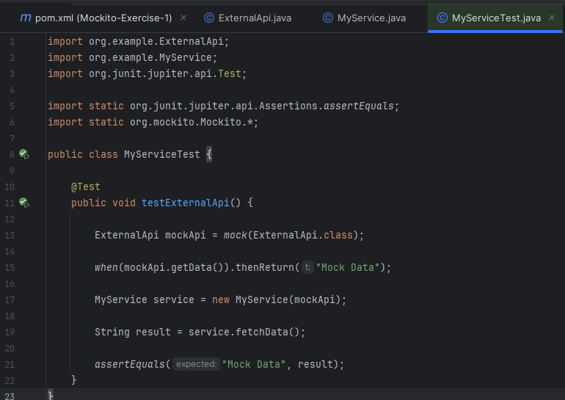

Output Screenshot:
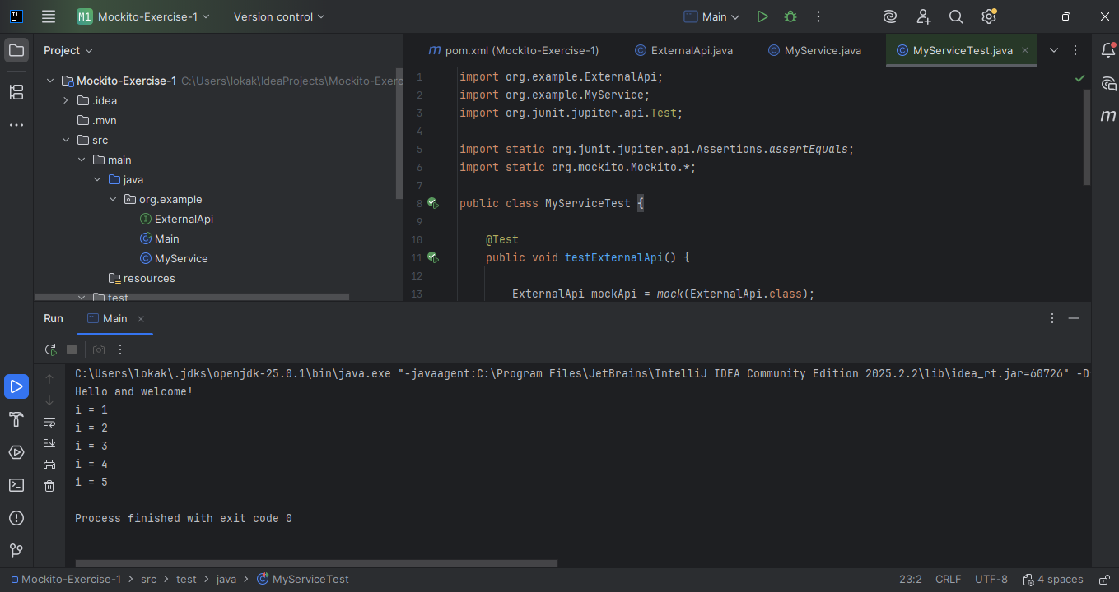

Exercise 2:Verifying Interactions:
Main.java:
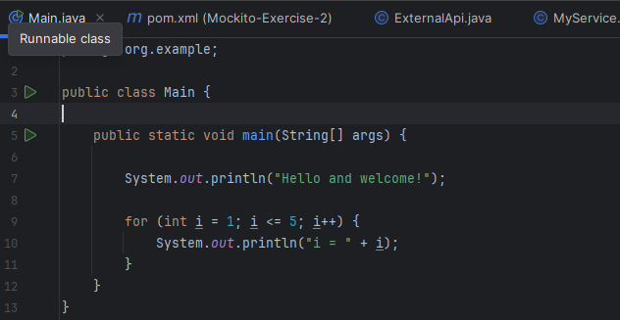

Pom.xml:
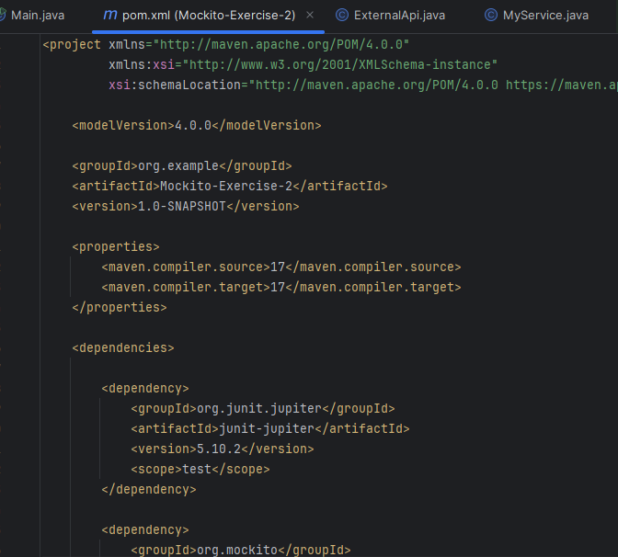
ExternalAPI.java:
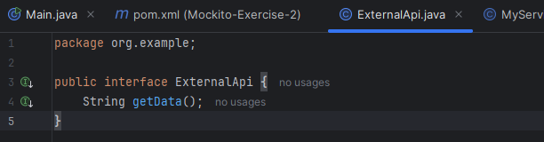
MyService.java:
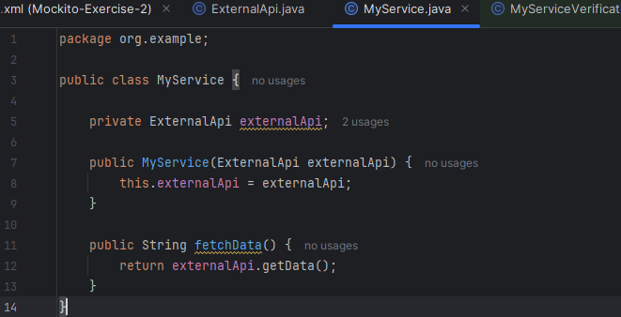
MyServiveVerificationTest.java:
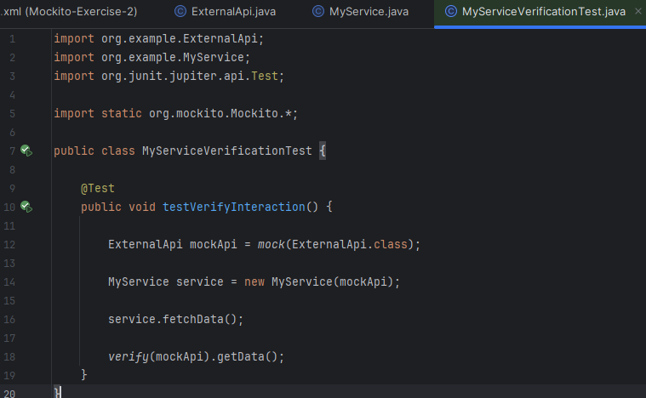

Output Screenshot:
